Project Design Phase
AI StudyBuddy
Project Name | AI StudyBuddy
Team ID | SWTID-2026-6718
Date | 27 September 2026

1. Design Overview
AI StudyBuddy is designed as a modular backend REST API that helps students convert their own study material into AI-generated learning aids. The design separates API routing, authentication, authorization, business logic, database operations and AI processing into independent components.
The system uses Node.js and Express.js as the backend platform, MongoDB as the database, and Google Gemini 2.5 Flash for AI processing. The design follows a layered (MVC-style) pattern with routes, controllers, models, middleware and utility modules kept separate.

2. Design Objectives
- Provide secure REST API access via JWT authentication
- Separate functionality according to user roles (Student / Admin)
- Manage the complete study-material lifecycle (upload, view, delete)
- Integrate Gemini for AI summarization, flashcards, quiz and study-plan generation
- Protect application resources through authentication and authorization middleware
- Support maintainable and scalable backend development

3. High-Level System Design
The overall system is divided into the following layers: Client (Frontend/Postman) → API Routing Layer → Middleware Layer (Auth/Upload) → Controller Layer → Service/Utility Layer → Database (MongoDB) / AI Service (Gemini).
API Layer | Security Layer | Business Layer | Data Layer
Auth APIs  Material APIs  Admin APIs | JWT authentication  Role authorization  Password hashing (bcrypt) | Material processing  AI generation (Gemini)  Admin processing | Users  Materials  Local Uploads Storage

4. Module Design

4.1 Authentication Module
Responsible for:
- User registration
- User login
- JWT access & refresh token generation
- Token verification
- Logout / session termination

4.2 Role Management Module
Supported roles: Student | Admin. Role-based middleware (protect, adminOnly) checks the authenticated user's role before performing restricted operations.

4.3 Material Management Module
Responsible for: uploading study files (.txt/.md/.pdf) via Multer, extracting text content, listing a student's materials, viewing and deleting a specific material, and persisting AI-generated outputs against that material.

4.4 AI Module
Responsible for generating: an AI summary, a configurable number of flashcards, an MCQ quiz, and a personalized study plan — using Google Gemini 2.5 Flash. Main operations: Summarize | Generate Flashcards | Generate Quiz | Generate Study Plan.

4.5 Admin Module
Responsible for: listing all users, deleting a user (with cascade deletion of their materials), and returning aggregate platform statistics (total users, total materials).

5. Database Design
The system uses two primary collections: Users and Materials.
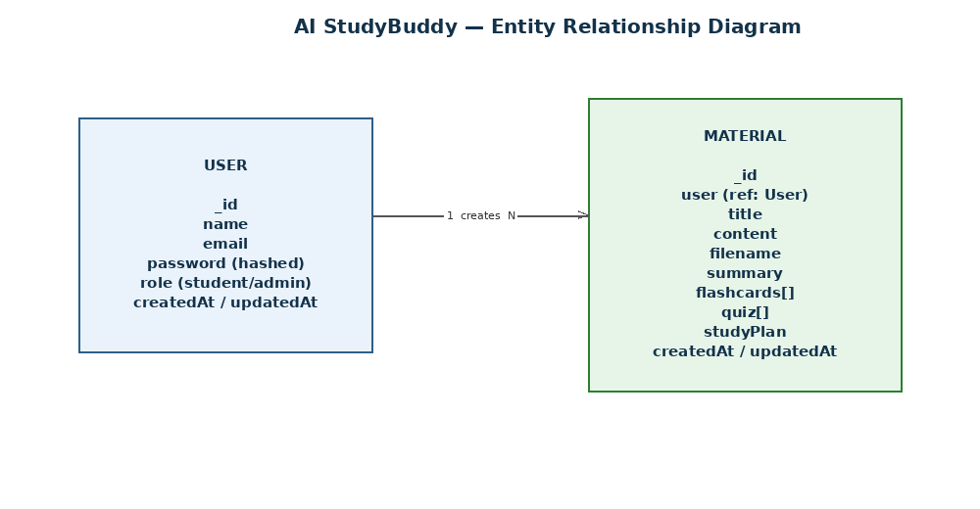
Figure 1: Entity Relationship Diagram — a User can create multiple Materials.

6. API Design

Authentication
POST /api/auth/register
POST /api/auth/login
POST /api/auth/refresh
POST /api/auth/logout

Materials
POST /api/materials/upload
GET /api/materials
GET /api/materials/:id
DELETE /api/materials/:id
POST /api/materials/:id/summarize
POST /api/materials/:id/flashcards
POST /api/materials/:id/quiz
POST /api/materials/:id/study-plan

Admin
GET /api/admin/users
DELETE /api/admin/users/:id
GET /api/admin/stats

7. AI Design
The AI subsystem is isolated in a dedicated utility (gemini.js) so AI processing does not become part of route or controller logic.
Summarize / Flashcards / Quiz | Study Plan
Material Content → Controller → Gemini Utility → Prompt Template → Google Gemini → Structured Result (summary / flashcards[] / quiz[]) | Goal, Hours/Day, Days + Material Content → Controller → Gemini Utility → Prompt Template → Google Gemini → Day-wise Study Plan

8. Prompt Design
Structured prompts are used to control the AI response:
- Summarize: provide the material content and request a concise summary.
- Flashcards: provide content + count and request question/answer pairs in a structured format.
- Quiz: provide content + count and request MCQs with options and the correct answer.
- Study Plan: provide the goal, hours/day, number of days and content, and request a day-wise plan.

9. Security Design
Security mechanisms include:
- bcrypt password hashing
- JWT authentication (short-lived access token, longer-lived refresh token)
- Role-based authorization (protect, adminOnly middleware)
- Centralized Express error handling

10. Data Flow Design
Authentication Flow | AI Generation Flow
User → Register/Login API → Auth Controller → User Model → MongoDB → JWT Response | Student → Material Endpoint (summarize/flashcards/quiz/plan) → JWT Verification → Material Controller → Gemini Utility → Google Gemini → Result saved to Material → Response

11. Role-Based Design
Role | Main Access
Student | Upload/view/delete own materials; generate AI summary, flashcards, quiz, and study plan for own materials
Admin | List all users; delete users (cascade); view platform statistics

12. Scalability Design
- AI functionality can be extended with additional Gemini prompts/services
- Additional roles can be introduced through the existing RBAC middleware
- Additional content-management modules can be added via separate controllers/routes
- MongoDB provides a document-store that scales horizontally

13. Design Outcome
The final design provides a clear separation between client interaction, API routing, security, business logic, database operations and AI processing — allowing AI StudyBuddy to function as a secure, modular backend REST API.

